MC900384266[1]MC900384266[1]

**EXTRAS**

•  Sheep Stage Puppet

• Felt Story- Have You Seen My Potty?

( pieces)

**PLEASE TAKE CARE. THIS ITEM IS WORTH:**

**$________________**

**BOOKS**

1. Does a Pig Flush? by Fred Elrich

2. Who’s in the Bathroom? by Jeanne Willis

3. Excuse me! A Little Book of Manners, by Karen Katz

4. Have You Seen my Potty? By Mij Kelly

5. The Prince and the Potty, by Wendy Lewison

6. Once upon a Potty, by Alona Frankel

7. Time to Pee, by Mo Willems

8. The eentsy, weentsy spider, by Joanna Cole

9. First Art, by MaryAnn Kohl

The following templates include the contents of

the El Dorado County

Library Storytime kits.

To edit the contents,

click on the text box,

MC900384266[1]

PICTURE BOOKS

Does a Pig Flush? by Fred Elrich

Who’s in the Bathroom? by Jeanne Willis

Excuse me! A Little Book of Manners, by Karen Katz

Have You Seen my Potty? By Mij Kelly

The Prince and the Potty, by Wendy Lewison

Once upon a Potty, by Alona Frankel

Time to Pee, by Mo Willems

ACTIVITY BOOKS

The eentsy, weentsy spider, by Joanna Cole

First Art, by MaryAnn Kohl

FELT STORY

Have You Seen My Potty?

PUPPET

Sheep

(for use with “Have You Seen My Potty?”)

**FELT STORY – Have You Seen My Potty?**

**If you’re feeling crafty…**

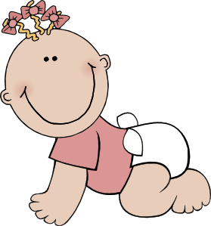



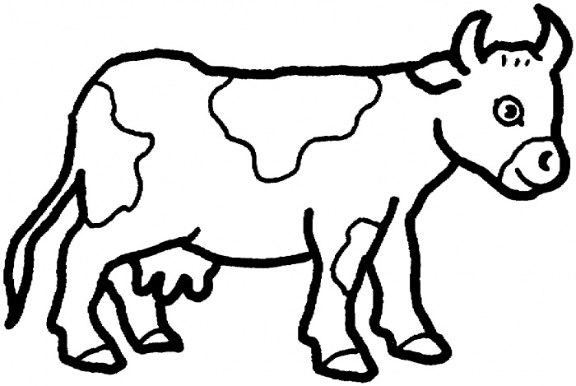

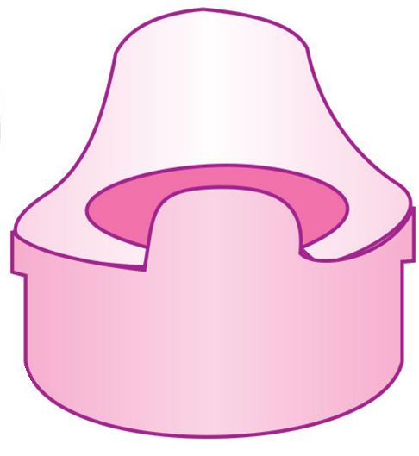

MC900417464[2]



MC900417476[1]

MC900417474[1]



Five Little Babies Learning to go Potty

<http://www.youtube.com/watch?v=jwW5sWp8mJI>

**If you feel like shopping…**

Farm Animal Puppets, $15.99 from Storytime Felts & More

<https://www.storytimefeltsandmore.com/shop/farm-animal-puppets-630.html>

**PUPPET**

2884-SheepStage Puppet, $17.99

From Folkmanis

