The following templates include the contents of
the El Dorado County
Library Storytime kits.
To edit the contents,
click on the text box,

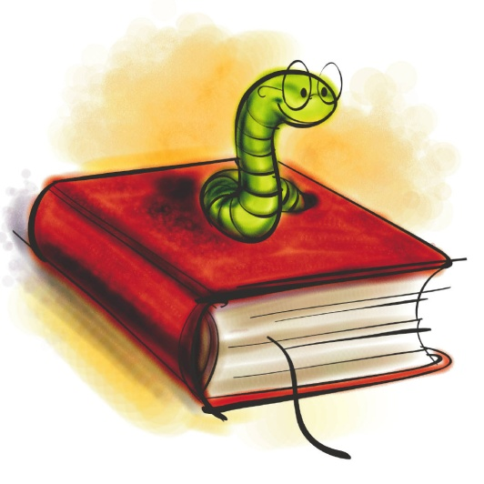
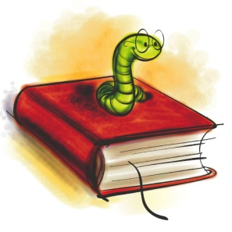
EXTRAS
•Lion Puppet
• Felt Story- Wild About Books ( pieces)

PLEASE TAKE CARE. THIS ITEM IS WORTH:
$________________

BOOKS
1. The Incredible Book Eating Boy, by Oliver Jeffers
2. L is for Library, by Sonya Terry
3. Lola at the Library, by Anna McQuinn
4. The Shelf Elf, by Jackie Hopkins
5. When the Library Lights Go Out, by Megan McDonald
6. Wild About Books, by Judy Sierra
7. Wolves, by Emily Gravett
8. The eentsy, weentsy spide, by Joanna Cole
9. First Art, by MaryAnn Kohl

PICTURE BOOKS
The Incredible Book Eating Boy, by Oliver Jeffers
L is for Library, by Sonya Terry
Lola at the Library, by Anna McQuinn
The Shelf Elf, by Jackie Hopkins
When the Library Lights Go Out, by Megan McDonald
Wild About Books, by Judy Sierra
Wolves, by Emily Gravett

ACTIVITY BOOKS
The eentsy, weentsy spide, by Joanna Cole
First Art, by MaryAnn Kohl

FELT STORY
Wild About Books, by Judy Sierra

PUPPET
Lion

FELT STORY – WILD ABOUT BOOKS

If you’re feeling crafty…

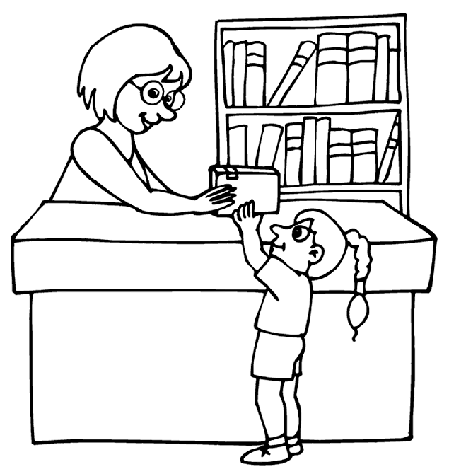
1.Librarian

2.Penguin 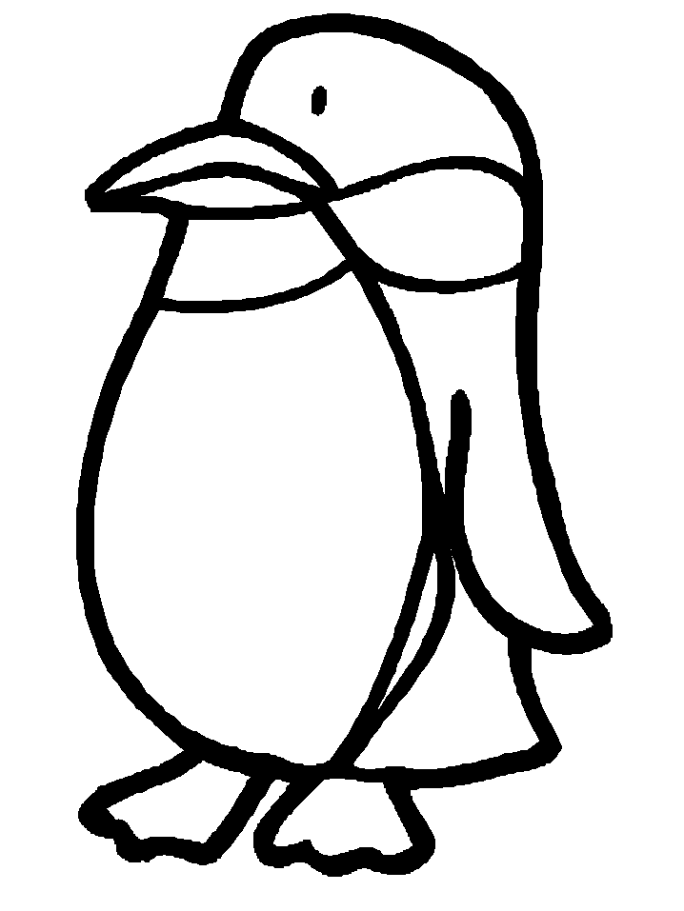

3.Hippo
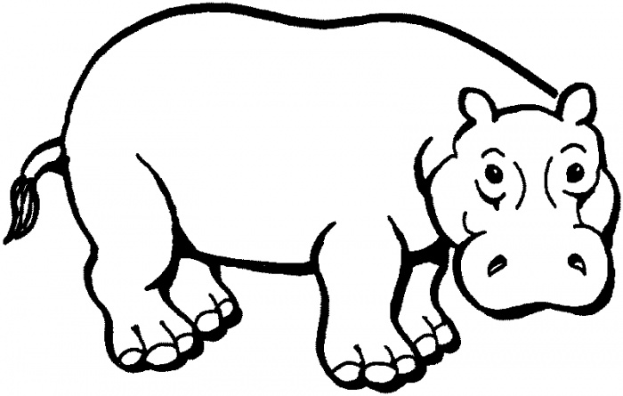

4. Hyena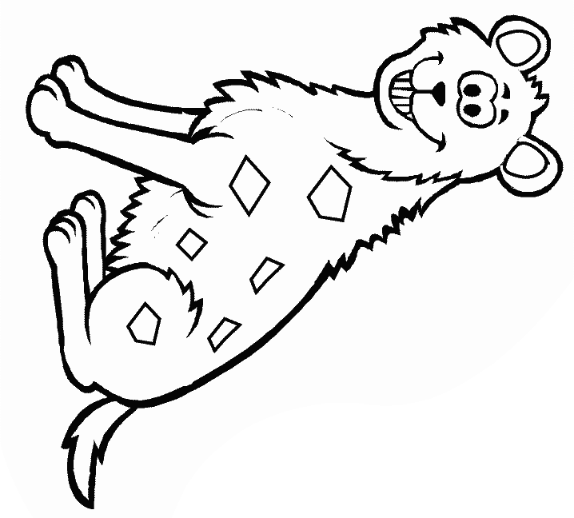
5. Snake (with red belly)

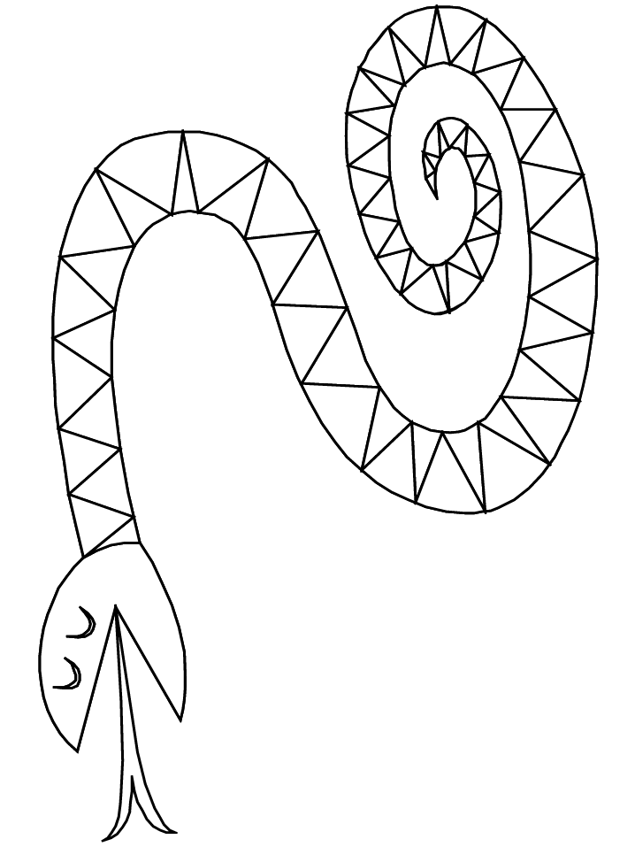
6. Panda
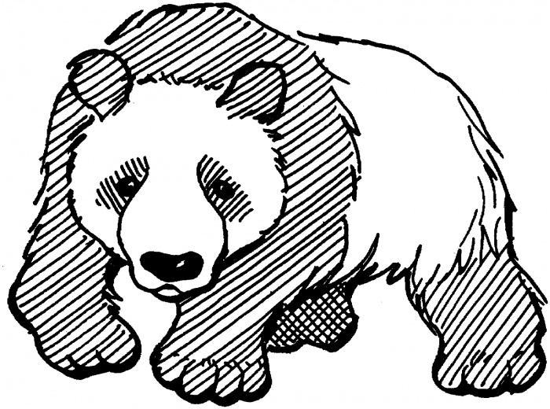

7.Two bunnies

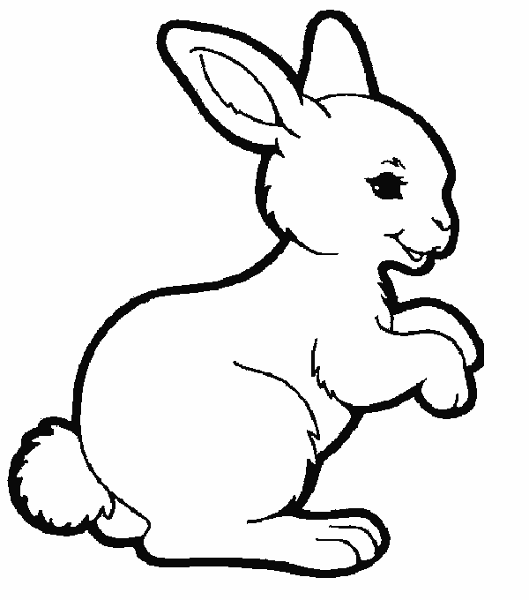
8.Otter
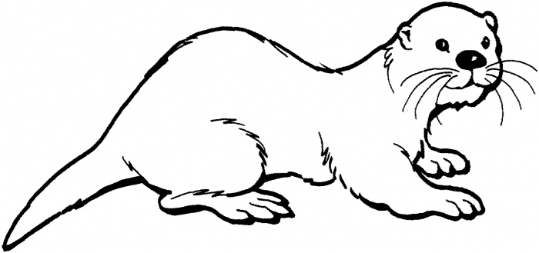

9.Lizard
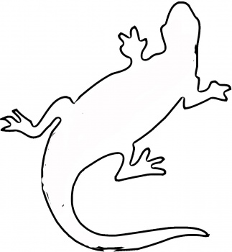

10.Baboon

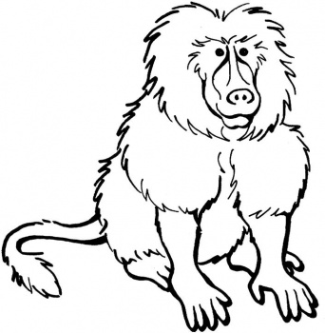

11.Bear

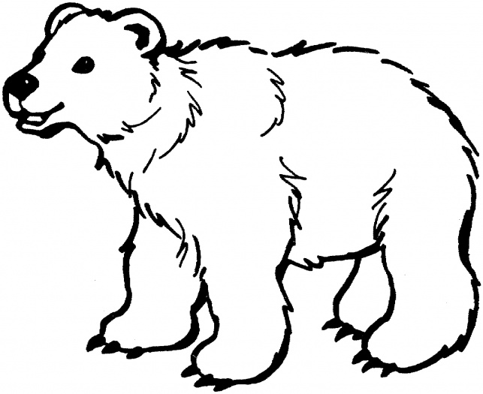

12. Raccoon
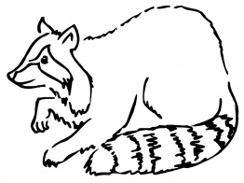
If you feel like shopping…

25808-Jungle Animals, Play Board $16.95 from Little Folk Visuals
http://littlefolkvisuals.com/index.php?page=shop.product_details&flypage=flypage_images.tpl&product_id=296&category_id=22&option=com_virtuemart&Itemid=84

PUPPET
2562-Lion Stage Puppet from Folkmanis, $21.99
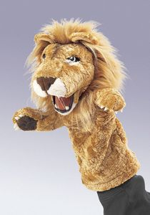

http://www.folkmanis.com/Prod-67-1-91-4/Lion_Stage_Puppet.htm

