STORYTIME KIT  Ducks |  | STORYTIME KIT  Ducks | 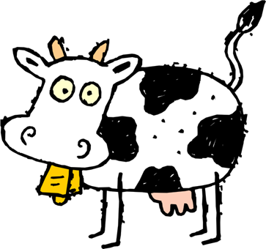 | STORYTIME KIT  Ducks
STORYTIME KIT  Ducks |  | STORYTIME KIT  Ducks |  | STORYTIME KIT  Ducks
STORYTIME KIT  Ducks |  | STORYTIME KIT  Ducks |  | STORYTIME KIT  Ducks
STORYTIME KIT  Ducks |  | STORYTIME KIT  Ducks |  | STORYTIME KIT  Ducks
STORYTIME KIT  Ducks |  | STORYTIME KIT  Ducks |  | STORYTIME KIT  Ducks
STORYTIME KIT  Ducks |  | STORYTIME KIT  Ducks |  | STORYTIME KIT  Ducks
STORYTIME KIT  Ducks |  | STORYTIME KIT  Ducks |  | STORYTIME KIT  Ducks
STORYTIME KIT  Ducks |  | STORYTIME KIT  Ducks |  | STORYTIME KIT  Ducks
STORYTIME KIT  Ducks |  | STORYTIME KIT  Ducks |  | STORYTIME KIT  Ducks
STORYTIME KIT  Ducks |  | STORYTIME KIT  Ducks |  | STORYTIME KIT  Ducks

