MC900436097[1]MC900436097[1]

**BOOKS**

1. A Ball for Daisy, by Chris Raschka

2. Oh No, George!, by Chris Haughton

3. How Rocket Learned to Read, by Tad Hills

4. Hairy Maclary from Donaldson’s Dairy, by Lynley Dodd

5. The Hallo-Weiner, by Dav Pilkey

6. Bark, George, by Jules Feiffer

7. Fred Stays With Me, by Nancy Coffelt

8. The Eentsy Weentsy Spide, by Joanna Cole

9. First Art, by MaryAnn Kohl

**EXTRAS**

• Puppet

• Felt Story – Bark, George, by Jules Feiffer

( pieces)

**PLEASE TAKE CARE! THIS ITEM IS WORTH:**

**$_____________________**

The following templates include the contents of

the El Dorado County

Library Storytime kits.

To edit the contents,

click on the text box,

MC900436097[1]

PICTURE BOOKS

A Ball for Daisy, by Chris Raschka

Oh No, George!, by Chris Haughton

How Rocket Learned to Read, by Tad Hills

Hairy Maclary from Donaldson’s Dairy, by Lynley Dodd

The Hallo-Weiner, by Dav Pilkey

Bark, George, by Jules Feiffer

Fred Stays With Me, by Nancy Coffelt

ACTIVITY BOOKS

The Eentsy Weentsy Spider, by Joanna Cole

First Art, by MaryAnn Kohl

FELT STORY

Bark, George, by Jules Feiffer

PUPPET

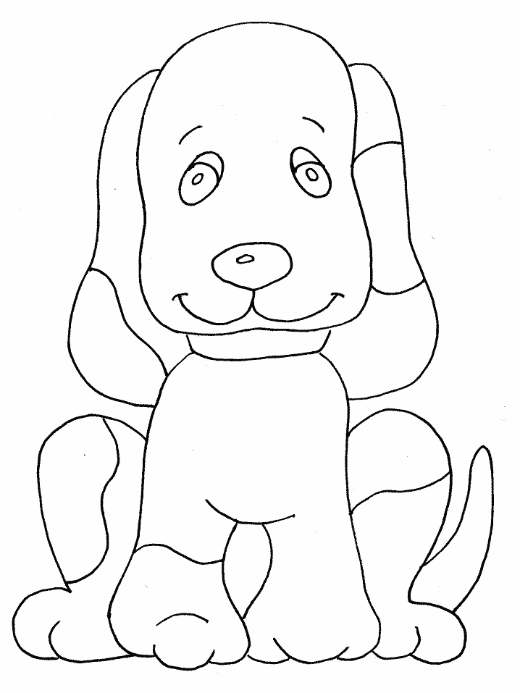**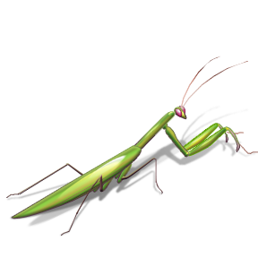FELT STORY – Bark, George**



MC900251667[1]

MC900356381[1]MC900391410[1]

MC900417460[1]

MC900417440[1]

**If you feel like shopping:**

22320-Wally the Weather Dog, $19.95 from Little Folk Visuals

<http://littlefolkvisuals.com/index.php?page=shop.product_details&flypage=flypage.tpl&product_id=184&category_id=9&keyword=dog&option=com_virtuemart&Itemid=84>

**PUPPET**

2915-Brown Dog Puppy, $19.99 from Folkmanis

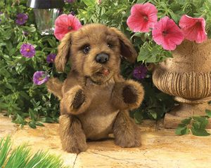

<http://www.folkmanis.com/Prod-67-1-272-1/Dog_Brown_Puppy.htm>